A basic handbook on how to create and upload a good YouTube video for a Business

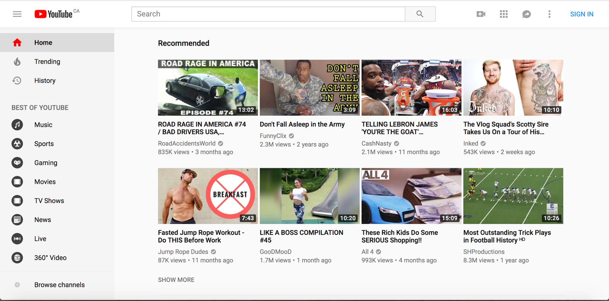
- First sign into Youtube and click on the user icon at the top right of the screen.

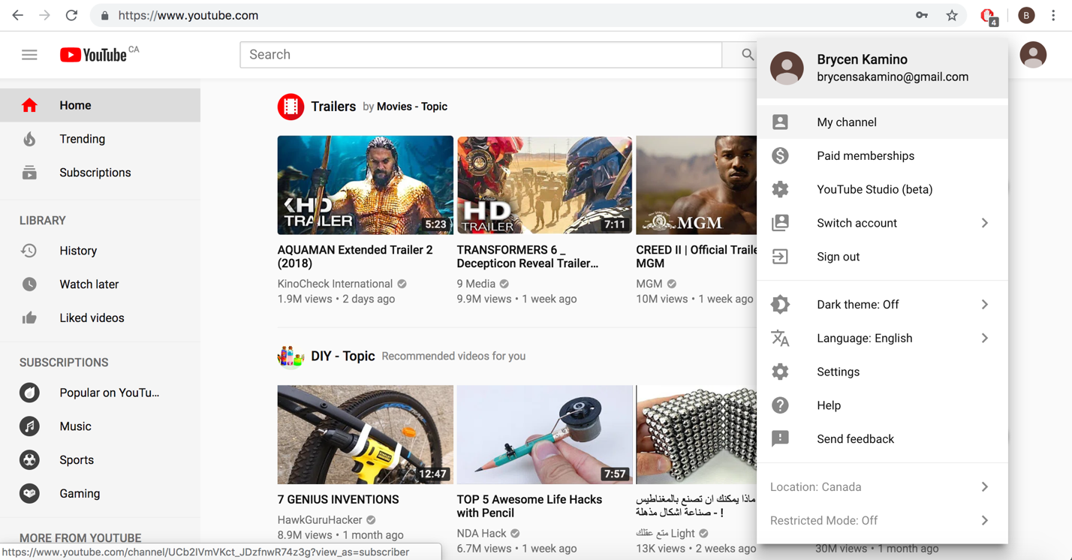
- Once you are signed in, clink on the gear icon “Settings” the click on “Create a new Channel”. You can then choose “Use a business or other name”, once that’s finished click create.

- To view/edit you channel click “My Channel”
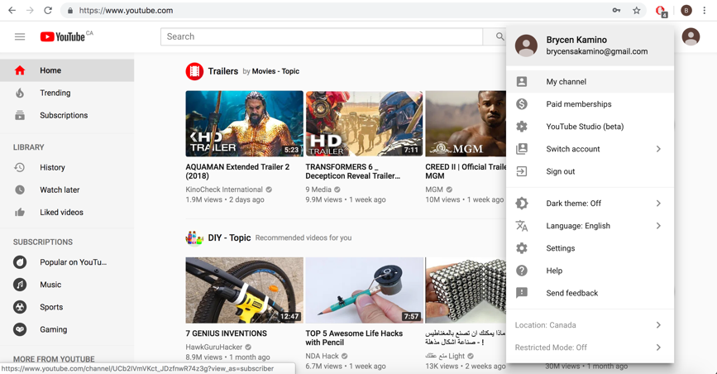

- From here click “Customize Channel”
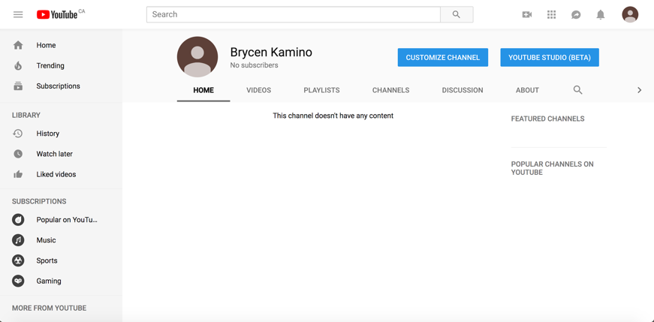

- Here you can add channel art, which is often times look as a banner. Here is also where you can view your videos, create different playlist, there’s a discussion board, and also an about section.
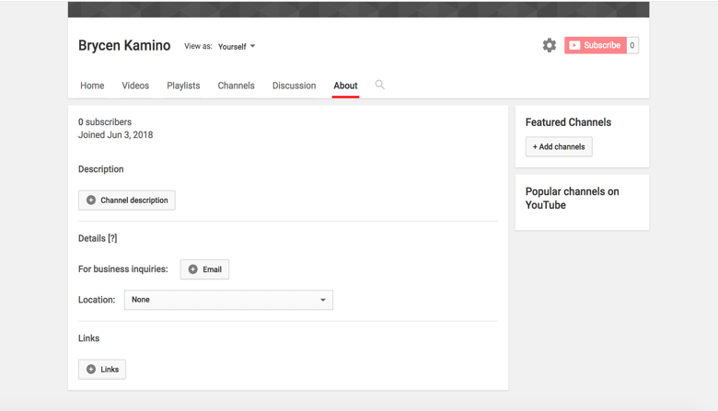
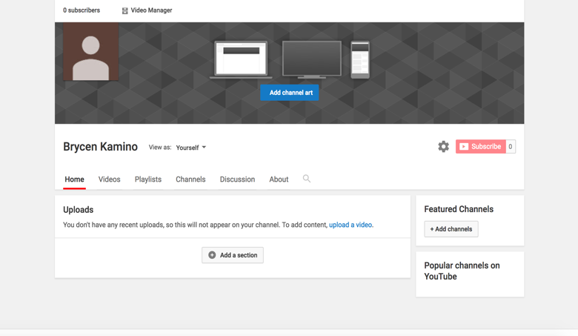

- In the “about” section, this is where you can add a description of your business, contact information, and also links to other social media outlets and/or websites.

- To upload a video, click the little camera icon then click “Upload video”
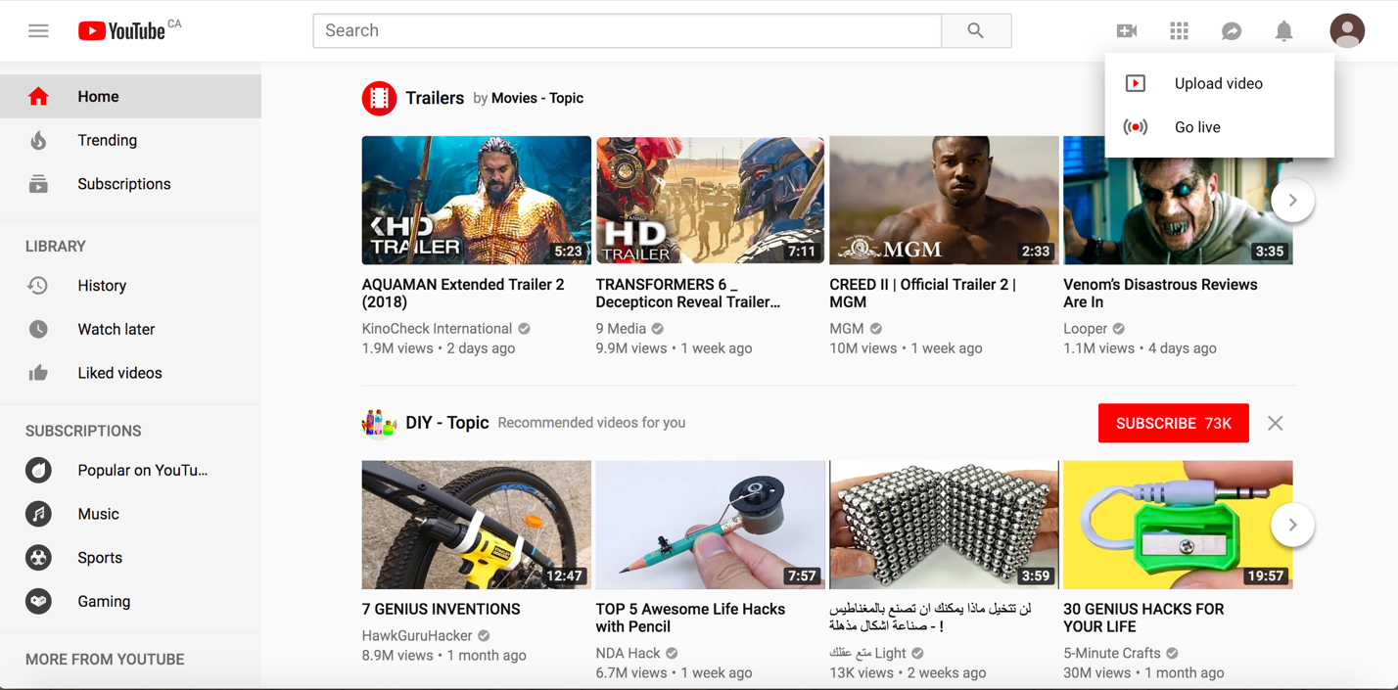

- From here you can either select, or drag and drop your video to get ready to publish it.
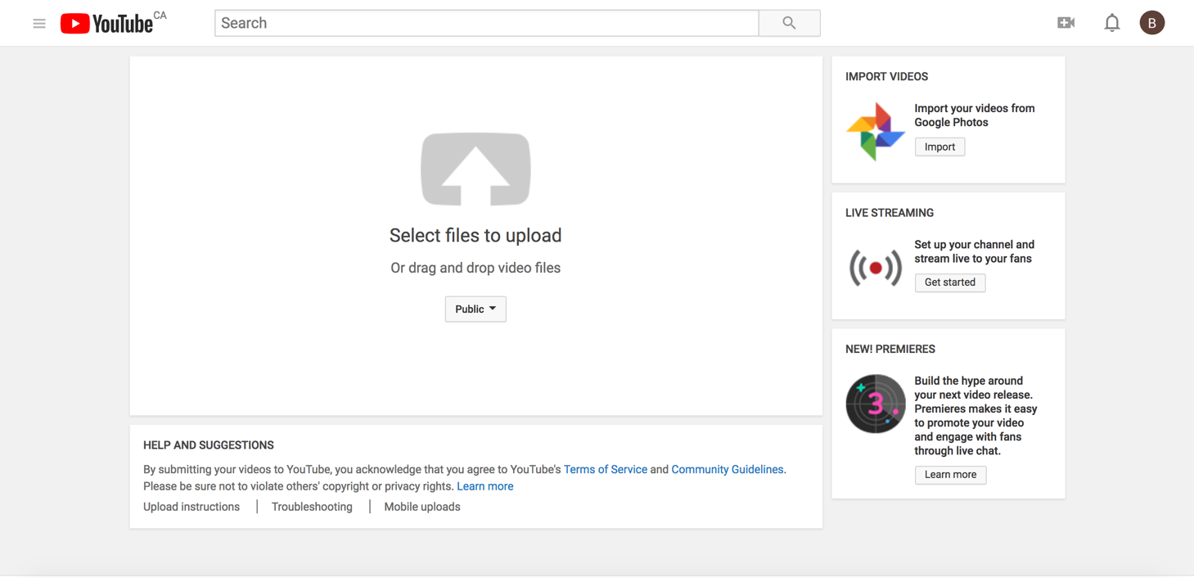

- Once your video is ready you will come to a screen like so, this is an important step because this is where you are able to implement Search engine optimization (SEO)
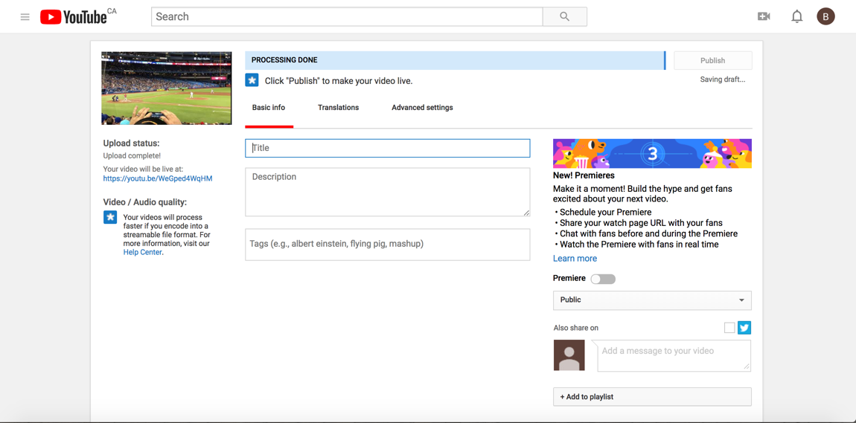

Title:
Besides the thumbnail (which we will explain later) the title is the first thing that the views eyes are drawn too. This will often times help determine whether or not the viewer will click and watch your video. The title should be short and sweet but also include some key words.

Description:
The description should also be brief and include some keywords, YouTube will only display the first two or three lines of text (100 characters) when someone is searching for a video. However, in the description you can add the full recipe of whatever you are making in the so viewers will be able to make it if they please.

By having a keyword-rich (but not heavy) title and description can really help promote your business and as you post more you will be able to see what words work best for each of your videos.

Tags:
Tags are used so YouTube can figure out how to associate your video with similar videos. When added tags it is important to lead with the most important keywords first and try to minimize having irrelevant keywords as it will just be a waste.


Here is an example of a video on YouTube when I searched for “Pet Sitting”

There is a custom thumbnail, a good title, and a good description (keyword(s) are in bold)
- Before uploading your video, it is important that you verify your YouTube channel (which is free), by verifying your channel it will allow you to upload longer videos, add custom thumbnails, and many more cool features. To verify your channel just scroll down from where you added your title, description, and tags. You should see a little question mark.
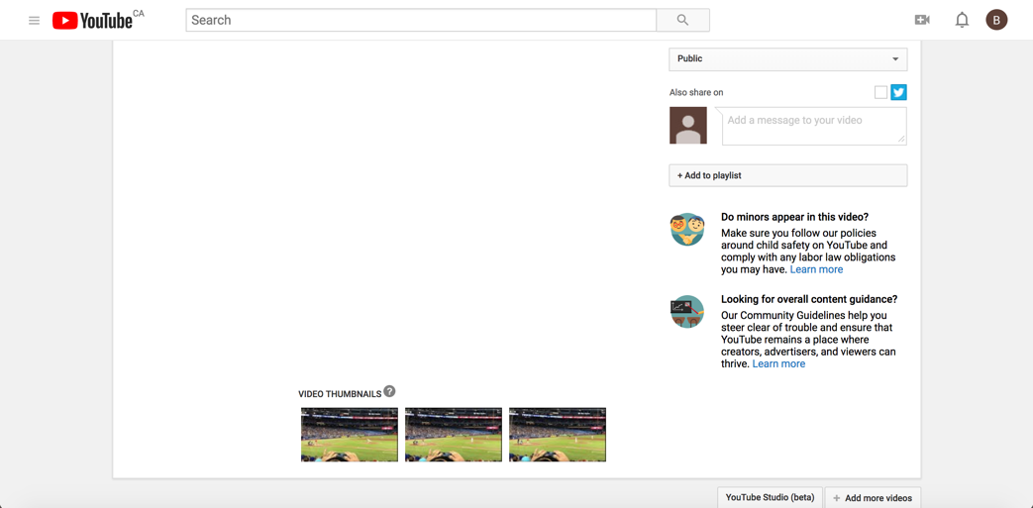

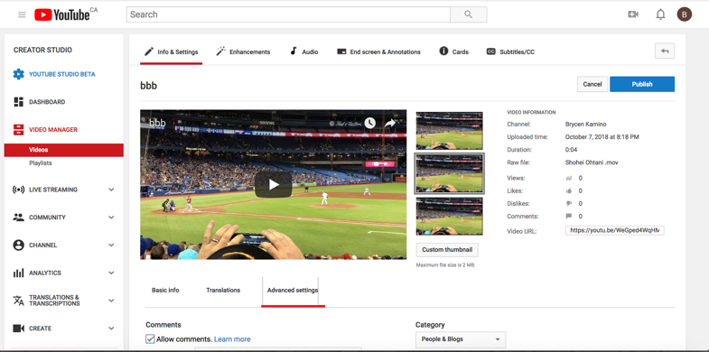
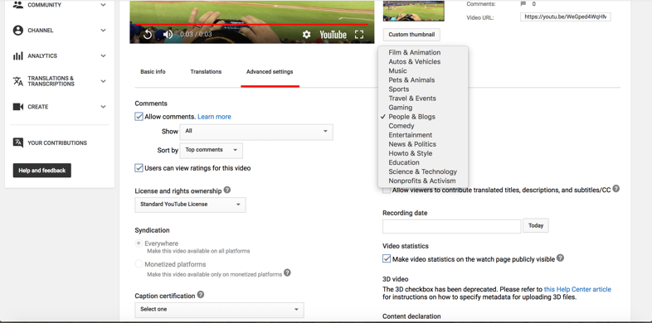
- Once you verify your YouTube channel you can access a more advance video settings, to keep it simple however the only things that will be useful in the advance settings is adding a custom thumbnail and being able to selecting which category you want your videos to be categorized in and

- The thumbnail is the face of your video and helps determine whether of not your video will be watched by the viewers. So, it is important to have an attractive thumbnail (see example on page before)

- Once you add everything you want into your video it’s time to publish it and let the viewers see what you have to offer.
